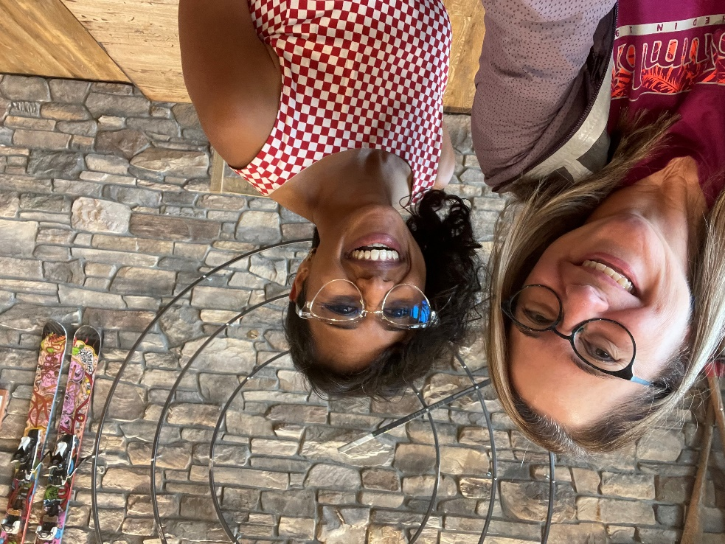

Weytk,
My name is Heather Wisla. I greet you from the traditional and unceded lands of the Tk'emlúps te Secwépemc. The region that Thompson Rivers University serves also extends into the territories of the St’át’imc, Tŝilhqot'in, Nuxalk, Dakelh and Nlaka’pamux.
It was on the lands of the Nlaka’pamux that I began my career with Thompson Rivers University, as Community Coordinator for Lytton. Lytton is located about 200 km northeast of Vancouver, at the junction of the Fraser and Thompson rivers. In June 2021, Lytton made headlines for reaching record highs of 49.5 C. The very next day a wildfire destroyed about 90% of the village’s structures, and two people sadly lost their lives. Lytton is a small, rural, highly indigenous community, and it has taken three years before any major rebuilding has gotten underway. Lytton’s fate highlights the urgency of the climate crisis, and the exceptional challenges it poses to Indigenous communities, something you all know very well.
In addition to being a Community Coordinator, I have worked for TRU in a variety of other roles including Academic Advisor and International Mobility Officer. I am now a University Instructor for our Faculty of Arts, Department of Communication and Visual Arts, where I teach professional writing and speech communications to undergraduate students.
I have a certificate in Teaching English as a Second Language and two university degrees, and am presently working on completing my third. I am a PhD Candidate in Languages, Cultures and Literacies at Simon Fraser University. My interest in cultures and languages stems not just from my professional work experience, but also my personal life. I grew up in a bilingual household, using both English and Sign Language, my youngest brother being deaf. I have had the opportunity to travel to a number of places, including Belize, Britain, Cuba, Germany, Guatemala, Honduras, Mexico, Qatar, South Africa and the USA. I am also a mother to three (now young adults), and grandmother to a bright and busy five-year old girl.
Reading through Volume 8 Special Edition of Knowledge Makers, I am so impressed by all of your writing and research. I feel very honoured to be invited to help you better share your understandings with others. I hope to provide you with lots of tools and tips to give you more confidence in all types of public speaking situations.
In advance of our session, please give some thought to these questions - who is the best public speaker you have ever watched personally or seen via video? What makes them so memorable?
We are lucky to have so many great resources available to us online. Here are a few videos I suggest you watch in advance of our session. Some of these were recommended to me by my former students. In total, the viewing time adds up to about 96 minutes. If you don’t have time or are unable to access them, no worries. I look forward to meeting you via Zoom very soon.

How to Make Stress your Friend - Kelly McGonigle (14:15)
Setting a positive attitude towards stressful events (such as public speaking).
https://www.ted.com/talks/kelly_mcgonigal_how_to_make_stress_your_friend

How to Avoid Death by PowerPoint - David JP Phillips - 2014 (20:31)
Tips for best practices in building slides.
https://www.youtube.com/watch?v=Iwpi1Lm6dFo&ab_channel=TEDxTalks

World Champion of Public Speaking - Cyril Jr. Dim - 2022 (8 minutes)
https://www.youtube.com/watch?v=lvYu29BpenY&ab_channel=ToastmastersInternational

Inside the Mind of a Master Procrastinator - Tim Urban - 2016 (13:54)
Excellent demonstration of the effective use of visual aids.
https://www.ted.com/talks/tim_urban_inside_the_mind_of_a_master_procrastinator

The Danger of a Single Story - Chimamanda Ngozi Adichie - 2009 (19:16)
Effective storytelling and use of voice.
https://www.youtube.com/watch?v=D9Ihs241zeg&ab_channel=TED

This country isn’t just carbon neutral, its carbon negative- Tshering Tobgay, Prime Minister of Bhutan (18:44)
Beautifully designed slides, and great use of clothing as a prop.
https://www.ted.com/talks/tshering_tobgay_this_country_isn_t_just_carbon_neutral_it_s_carbon_negative/transcript

4 Essential Body Language Tips - Dananjaya Hettiarachchi - 2014 Toastmasters International World Champion (2:27)
https://www.youtube.com/watch?v=ZK3jSXYBNak&ab_channel=BusinessInsider

